Seoyeon’s Research Journal

# Plan for the summer

* Lit survey on the online learning to learn what’s going on to pick your topic (due June 8)
* Find a topic (due June 22)
* Do a real research on the topic

# Research ideas

* Motivation and self-regulated learning
* Better engagement due to the adaptiveness of the courseware
* Reinforcement Learning for adaptive and optimal course contents organization
* Automated skill model discovery
* Deep learning for Quiz generation
* Wheel-spinning detector
* How do we measure the *synergetic competency*?

# Brainstorming for NY!!

* Too few VC/CC problems -- what does this imply?
* What does the synergetic learning for high school math look like?
* Can we verify that the current ACT book could be better by adding more VC/CC problems to promote better *synergetic learning*? (see below)
* 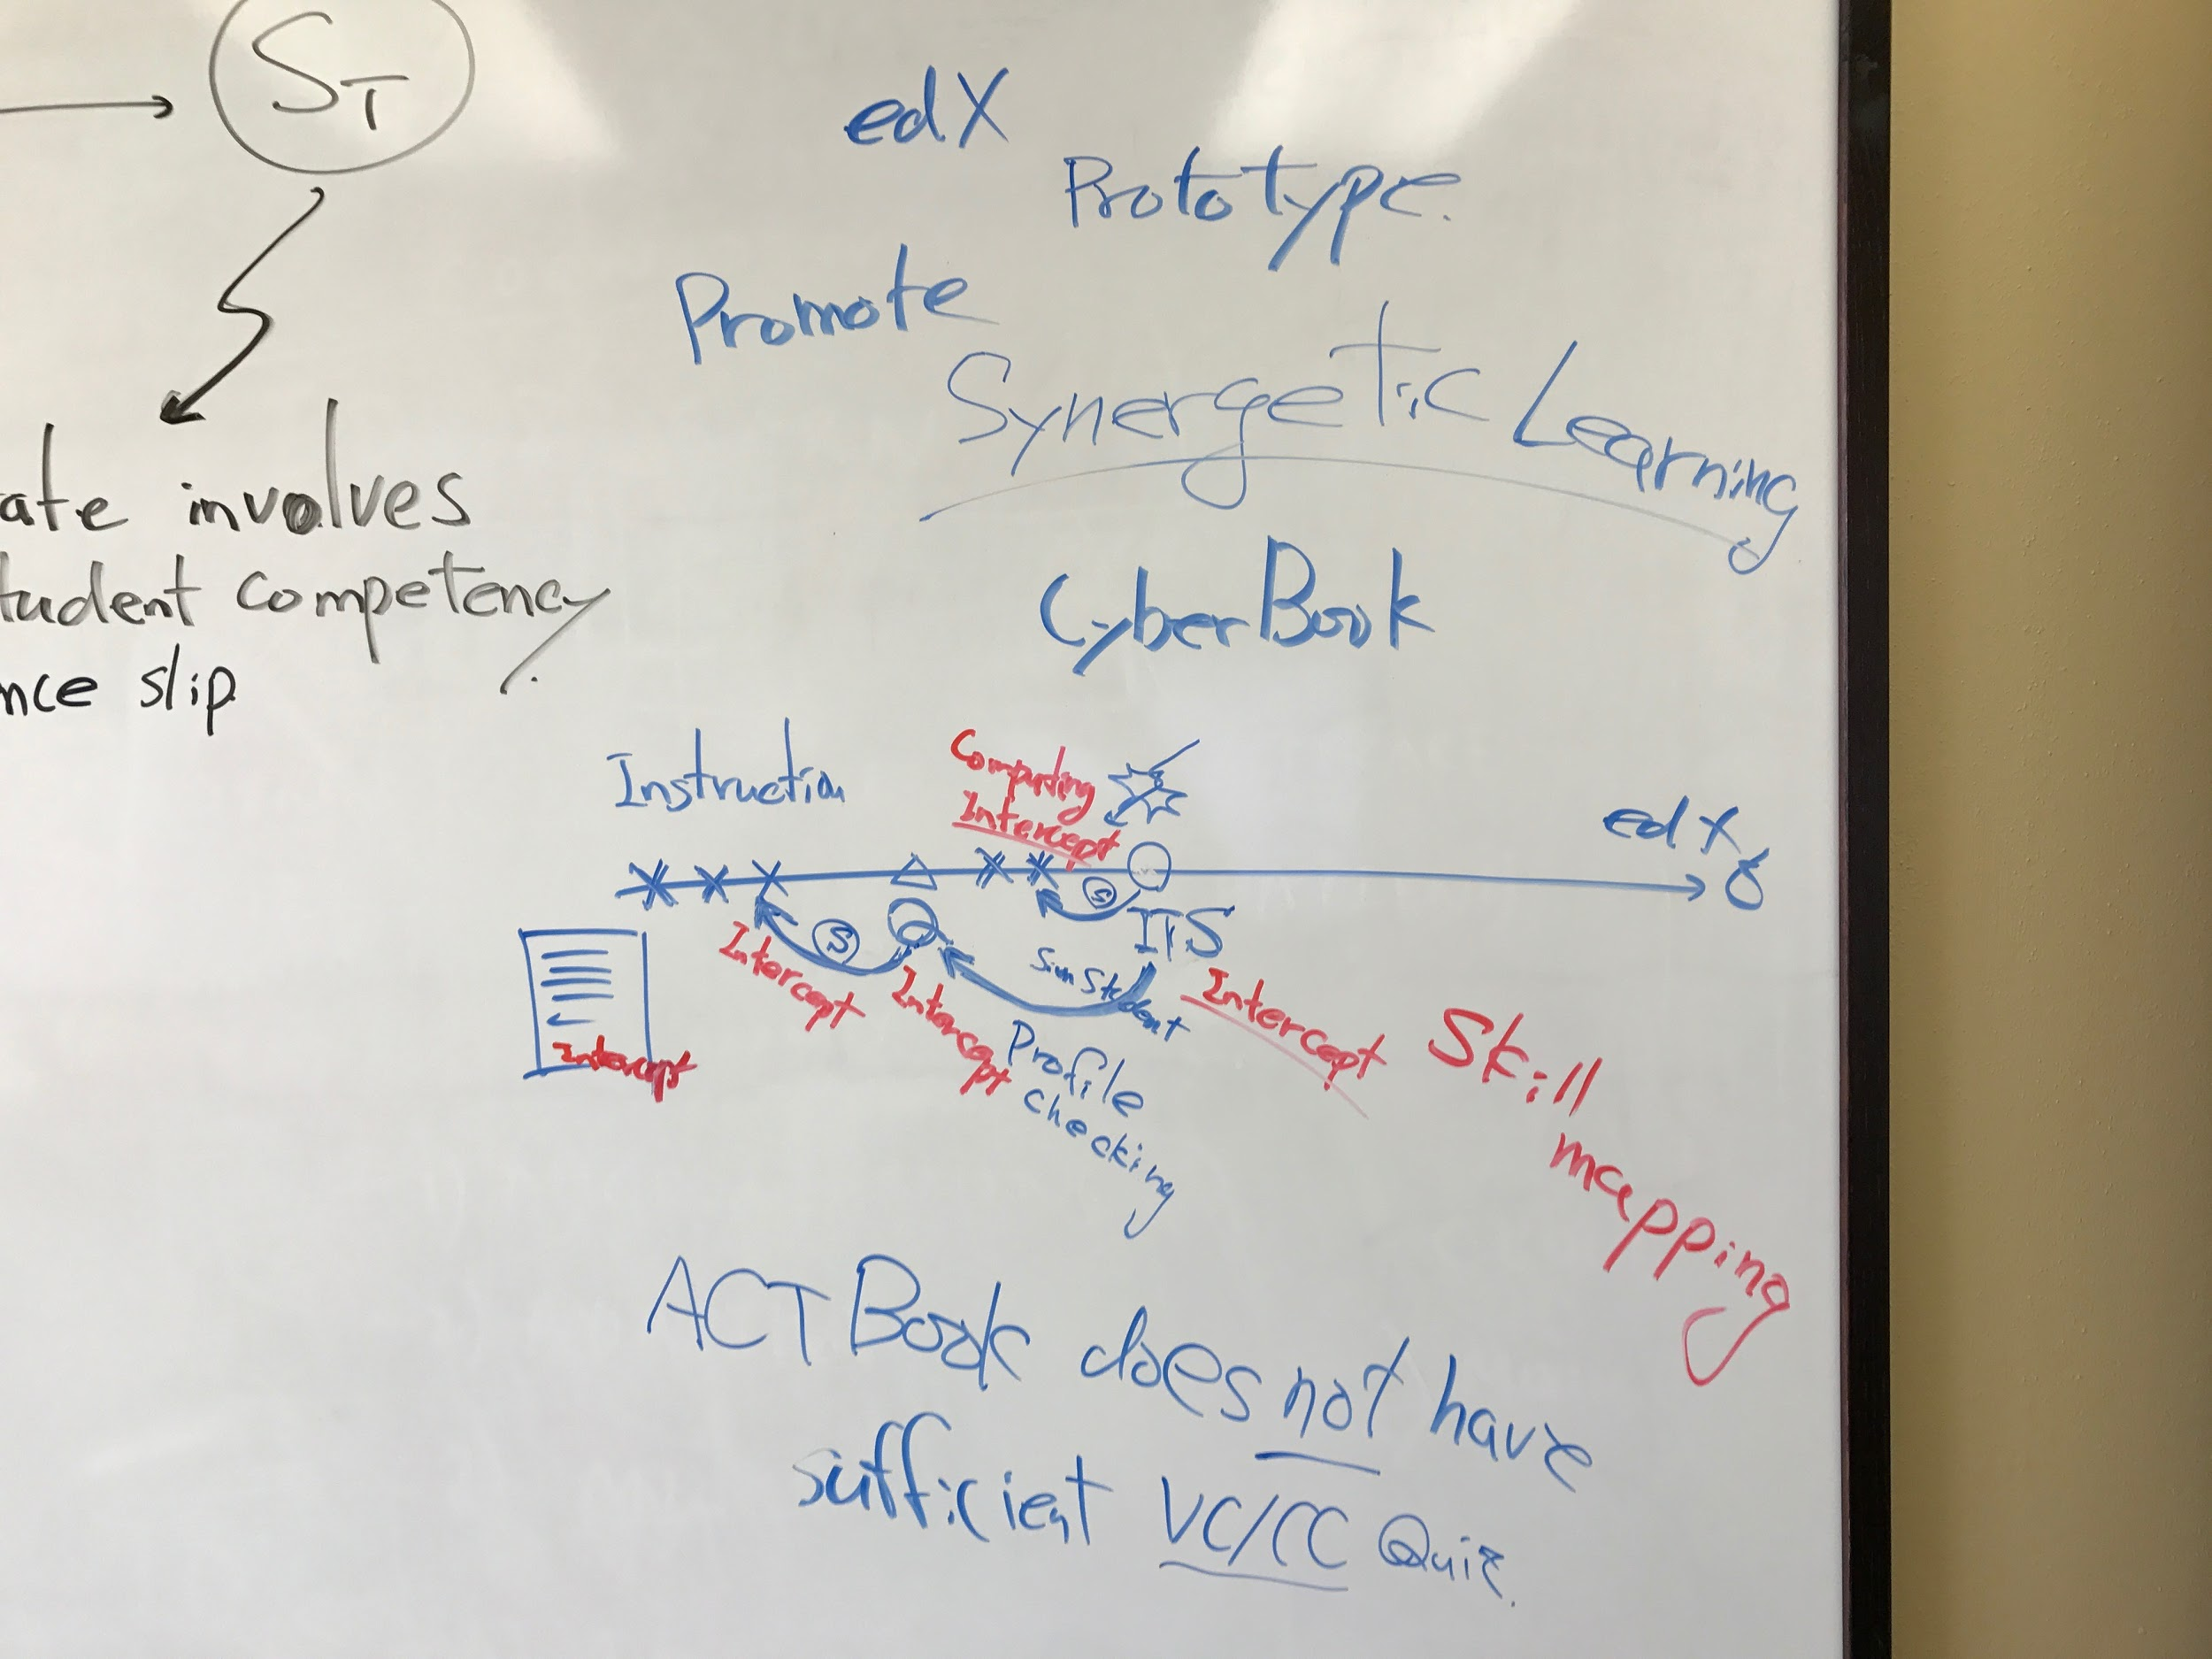
  + Can ITS/Cog Tutor (for problem solving skills) associate the lack of student’s knowledge to either the written instruction or the related conceptual knowledge (aka multiple choice question)?
  + Can Cog Tutor review the student’s profile to know if the student have sufficient understand for the related conceptual knowledge?
  + Those inquire would provide the Cog Tutor with the knowledge about what scaffolding is necessary for the student -- navigate to a related written text on how to solve (given the underlying concept is already grasped) vs. navigate to a related written text on the underlying concept (in the case the student’s proficiency on the conceptual quiz is not sufficient).
* To pilot this idea, we can prototype a section of ACT Book (which Seoyeon has already started) and manually tag skills. See if the ACT Book has sufficient number of conceptual quiz problems.
  + Use our lab version of Open edX and implement the section.
  + Develop a sufficient number of Cog Tutors and convert them into Model Tracing Tutors (using SimStudent) to extract skills
  + Manually tag skills among Cog Tutors, Multiple Choice Questions (i.e., VC/CC problems), and written text instructions
* Potential interesting claim: ACT Book does not have sufficient conceptual quiz (i.e., VC/CC problems) to promote the synergetic learning.

# Plan for NY!!

* Convert ETT into MTT — three way meeting with Vishnu
  + Re-compute the tutor-skill mapping (aks hybrid skill discovery and association)
* Ask Sharma to make the association between SimStudent generated skills and instruction (paragph about concept)
* Ask Donna to brainstorm formative assessments
* The theme of the AERA paper
  + Competency-based online course design
  + Demonstration of hybrid skill discovery and association (Tutor / Skill)
  + Application of text mining for skill / “concept” association

**Coordinate Geometry Questions skil & missing part**

|  |  |  |  |  |
| --- | --- | --- | --- | --- |
| **Q #** | **Step #** | **skill(matching concept#)** | **Missing part** | **improvement** |
| 17 | 7/9 | x coordinate of y-intercept(74) |  |  |
| 11/13/15/17/21 | copy |  |  |
| 19 | Multiplying / Simplification |  |  |
| 23 | divide (6) | ‘Divide both sides by sth’ is missing |  |
| 17_2 | 1/3/5/11/29/31/33/35/37 | copy |  |  |
| 7/9 | isolating y (63)  solving 'in terms of' y(64) | Overall, the steps for solving the equation are missing. It might be because these steps are too basic to handle in this book. However, this is kind of ironic because this book handles ‘the subtraction or addition of the signed number,’ which are also basic concepts. | Add instruction about how to solve the equation (procedural knowledge?) |
| 13/15/17 | divide (6) |  |  |
| 19/21 | x coordinate of y-intercept(73__) |  |  |
| 39 | Multiplying and simplifying |  |  |
| 32(73) | 1/9/11/33/17 | copy |  |  |
| 13/15/35 | isolating y (63)/ solving 'in terms of' y(64) |  |  |
| 19/37  25/39/41 | divide |  |  |
| 43 | slope (73) |  |  |
| 34 | 1/3/5/35/15/ | copy |  |  |
| 7/9/37 | isolating y (63)/ solving 'in terms of' y(64) |  |  |
| 39/19/17/41/  43 | divide |  |  |
| 45/49 | writing an equation with the slope (73) |  |  |
| 51 | writing an equation with the y-intercept (74) |  |  |
| 37 | 1/3 | reading y-coordinate | The ‘Coordinate geometry’ section starts with ‘finding the distance between two points’, not handling how to read x, y coordinates. This might be because this part is too basic, but still it’s not clear. | Add instruction about the concept of coordinates. |
| 5/7 | copy/ Finding the shortest distance between a line and a point | The shortest line to a line from a point will be a line perpendicular to the line. | Add instructions. |
| 9 | subtract(5) |  |  |
| 39 | 1/23/45/25/3/67/47/27/69/5/49/29/71/7/51 | finding the distance between two points (71) |  |  |
| 31/73/9/53/33/75/11/55 | add |  |  |
| 35/ 77/ 13/57/37/79/15/59 | square | The concepts of ‘square’ and ‘square root’ are not enough even though they are explained on pages 120~121. | Add instruction/ CC questions |
| 41/83/19/63 | square root |
| 39_2 | 1/3 | Read the length of legs | missing(maybe it’s too basic) |  |
| 5 | Know the special leg to leg ratio of a right triangle(85) |  |  |
| 39_3 | 1/3 | Read the length of legs |  |  |
| 5/21 | pythagorean theorem(84) | * How to differentiate this step from copy |  |
| 23/25 | square |  |  |
| 27 | add |  |  |
| 29 | Root square |  |  |
| 50  (multiple question) |  | isolating y (63)/ solving 'in terms of' y(64) | The key concept for solving this question is missing; “lines with no common solution have the same slope and are parallel.” | Add instruction about how to relate the equations and geometry. / CC questions. |
|  | divide |
|  | writing an equation with the slope (73) |
| 55 | 43/1/89/151/47/91/131/25/67/3/95/69/93/153/49/45/7/133 | finding the distance between two points (71) |  |  |
| 115/51/117/9/137/11/157/135/53/99/155/97/163/59/143/17/123/105 | add |  |  |
| 55/161/103/121/15/57/119/101/13/139/141/159 | square |  |  |
| 145/125/19/165/61/107 | calculating the area of the square (87) |  |  |
| 167/21/127/147/109/63 | square root |  |  |
| 55_2 | 19/1/21/3/23/5 | Calculating the area of triangle(83) | One of the keys to solve this problem is to know that the area of the square can be divided into two right triangles. |  |
| 25/7 | multiplying |  |  |
| 27/9 | copy |  |  |
| 29/11 | Divide |  |  |
| 31/13 | copy |  |  |
| 33/15 | multiplying |  |  |

Evidence-based feedback

Goal-driven design.

**Q matrix**

|  |  |  |  |  |  |  |  |  |  |
| --- | --- | --- | --- | --- | --- | --- | --- | --- | --- |
| Coordinate Geometry | | VV | | | | | | | M |
| skill | paragraph | 17 | 17_2 | 32 | 34 | 37 | 39 | 55 | 50 |
| copy |  | 0 | 0 | 0 | 0 | 0 |  |  |  |
| X coordinate of y-intercept | Explained in 74. | 0 | 0 |  |  |  |  |  |  |
| multiplying/simplification | 6. Multiplying/Dividing Signed numbers  Positives multiplied/divided with other positives are always positive. An even number of negative numbers, when multiplied or divided, will also be positive. However, if there is an odd number of negatives, the multiplication/division will be negative. For instance, (-2)*(-3)=6, but (-2)*(-3)*(-4)=-24. | 0 | 0 |  |  |  |  |  |  |
| divide | 0 | 0 | 0 | 0 |  |  |  | 0 |
| Isolating y/ solving ‘in terms of y’ | 63. Solving a linear equation  To solve an equation, isolate the variable. As long as you do the same thing to both sides of the equation, the equation is still balanced. To solve 5x-12=-2x+9, first get all the x terms on one side by adding 2x to both sides:7x-12=9. Then, add 12 to both sides:7x=21, then divide both sides by 7 to get:x=3.  64. Solving “in terms of”  To solve an equation for one variable in terms of another means to isolate the one variable that you are solving for on one side of the equation, leaving an expression containing the other variable on the other side. To solve 3x-10y=-5x+6y for x in terms of y, isolate x:  3x-10y=-5x+6y  3x+5x=6y+10y  8x=16y  x=2y |  | 0 | 0 | 0 |  |  |  | 0 |
| Writing an equation with the slope | 73. Using an equation to find the slope  To find the slope of a line from an equation, put the equation into the slope-intercept form: y=mx + b  Where the slope is m, and b is the y-intercept (the point where the line crosses the y-axis). To find the slope of the equation 3x+2y=4, isolate y, so it’s in slope-intercept form:  3x+2y=4  2y=-3x+4  y=-3/2x+2  The slope is -3/2 |  |  | 0 | 0 |  |  |  | 0 |
| Writing an equation with the y-intercept | 74. Using an equation to find an intercept  To find the y-intercept, you can either put the equation into y=mx+b (slope-intercept) form-in which case b is the y-intercept-or you can just plug x=0 into the equation and solve for y. The y-intercept is the point where the line crosses the y-axis, which means x=0. To find the x-intercept, plug y=0 into the equation and solve for x. |  |  |  | 0 |  |  |  |  |
| Reading y-coordinate |  |  |  |  |  | 0 |  |  |  |
| Finding the shortest distance between a line and a point |  |  |  |  |  | 0 |  |  |  |
| add/subtract | 5. Adding/ Subtracting signed numbers  To add a positive and negative, subtract the negative number from the positive number. For instance, -9+1 is the same as 1-9. Alternately, you can find the difference between the two numbers, and then keep the original sign of the larger number. Again using the example -9+1, the difference between 1 and 9 is 8, and since 9 was the larger number, keep the negative sign, so -9+1=-8.  Subtracting a negative number is the same as adding a positive. For example, think of 17-(-21) as 17+(+21).  To add or subtract a string of positives and negatives, add up all of the positive numbers, and add up all of the negative numbers. Then add those two sums together, keeping the sign of the greater sum. For instance, if you had the string 8+3-12+4-6-5, combine the positives:8+3+4=15. Combine the negatives: -12+(-6)+(-5)=-23. Now combine the two sums:15+(-23)=-8. |  |  |  |  | 0 | 0 | 0 |  |
| Finding the distance between two points | 71. Finding the distance between two points  To find the distance between points, use the Pythagorean theorem or special right triangles. The difference between $x_{1}$ and $x_{2}$ is one leg and the difference between the $y_{1}$ and $y_{2}$ is the other leg.    In the figure above, to find the distance between the points P and Q, draw a right triangle where $PQ$ is the hypotenuse. This makes a 3-4-5 right triangle, so $PQ$ =5.  You can also use the distance formula:    For instance, to find the distance between R(3,6) and S(5,-2): |  |  |  |  |  | 0 | 0 |  |
| square | y*y is the square of y, or $y^{2}$. |  |  |  |  |  | 0 | 0 |  |
| Square root | A fractional exponent indicates a root. ${(a)}^{1/n}=\sqrt[n]{a}$ (Read “the nth root of a”. If no “n” is present, the radical sign means a square root. $8^{1/3}$ =the cube root of 8=2 |  |  |  |  |  | 0 | 0 |  |
| Calculating the area of the square | 87. Areas of special quadrilaterals  Area of Rectangle=Length * Width  The area of a 7-by-3 rectangle is 7*3=21.    Area of Parallelogram=Base*Height  Just like with triangles, the base and the height must be perpendicular to each other, otherwise you cannot calculate the area of the parallelogram. The area of a parallelogram with a height of 4 and a base of 6 is 4*6=24.    Area of Square = ${(side)}^{2}$ The area of a square with sides of length 5 is $5^{2}$ =25.    Area of Trapezoid =($\frac{base1+base2}{2}$)*height  Think of it as the average of the bases (the two parallel sides) times the height (the length perpendicular to the bases-not the side length).    In trapezoid ABCD, you can use side AD for the height, since it’s already perpendicular to the bases. The average of the bases is ($\frac{2+14}{2}$)=8, so the area is 5*8, or 40. |  |  |  |  |  |  | 0 |  |

Question.

Do we need to measure/ How can we measure these explanations are sufficient or not? By expert verification? Or students’ outcome? (ex. How to solve the equation)

Codebook

CC : If the question is asking students to recall math concepts (or definitions) which are constant and the answer would be also constant, then it can be classified as CC.

VC : If the question is asking students to recall math concepts (or definitions) which are constant and variables can change randomly, then it can be classified as VC.

VV : If the question consists of variables and conditions that can change values and the answer would vary depends on variables, then it can be classified as VV.

|  |  |  |  |  |  |  |  |
| --- | --- | --- | --- | --- | --- | --- | --- |
|  | SMART-labelled key skills | | | | | |  |
| Human-labelled key skills | answer choices | equation | line | Right triangle | Square root | triangle | Grand Total |
| calculate the area of the square |  |  |  |  | 1 | 2 | 3 |
| determine a y-intercept by setting x=0 |  | 1 |  |  |  |  | 1 |
| determine a y-intercept from y=mx+b |  | 1 |  |  |  |  | 1 |
| determine slope from ax+by=c |  | 1 |  |  |  |  | 1 |
| find the distance between two points |  |  |  | 2 | 1 |  | 3 |
| find the distance from a point to a line |  |  | 1 |  |  |  | 1 |
| know when parallel lines have no solution | 1 |  |  |  |  |  | 1 |
| write the equation of line: y=mx+b |  | 1 |  |  |  |  | 1 |
| Grand Total | 1 | 4 | 1 | 2 | 2 | 2 | 12 |